7.2.4 Editors - 3D View - Header - Select Menu
Detailed Table of content 2
Object Mode - Select menu 3
Less 3
More 3
Child Extended 3
Parent extended 3
Child 4
Parent 4
Last Operator Select Hierarchy 4
Direction 4
Extended 4
All by Type 4
Last Operator Select By Type 4
Extend 4
Type 4
All by Layer 5
Last Operator Select by Layer 5
Match 5
Extend 5
Layer 5
By Pattern 5
Pattern 5
Case Sensitive 5
Extend 6
Last Operator Select Pattern 6
Pattern 6
Case Sensitive 6
Extend 6
Linked 6
Object Data 6
Material 6
Texture 6
Dupligroup 6
Particle System 6
Library 6
Library (Object Data) 7
Last Operator Select Linked 7
Extend 7
Type 7
Grouped 7
Last Operator Select Grouped 7
Extend 7
Type 7
Camera 7
Last Operator Select Camera 7
Extend 7
Mirror 8
Last Operator Select Mirror 8
Extend 8
Random 8
Last Operator Select Random 8
Percent 8
Random Seed 8
Action 8
Inverse 8
(De)Select All 8
Last Operator (De)Select All 8
Action 8
Invert 8
Deselect 8
Select 8
Toggle 9
Circle Select 9
Border Select 9
Lasso Select 9
Stroke Select 10

Detailed Table of content

Object Mode - Select menu

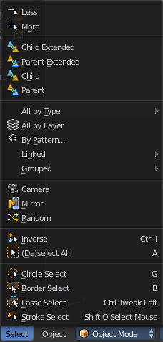
The select menu in Object mode is for all object types equal. It provides you with several selection methods.

Less
Less requires to have a parent or child relationship. It reduces the selection.

More
More requires to have a parent or child relationship. It expands the selection.

Child Extended
Child Extended requires to have a parent or child relationship. It selects the child object(s) of the currently selected object(s). But keeps the active object in the selection, even when it's not currently selected.

Parent extended
Parent extended requires to have a parent or child relationship. It selects the parent object of the currently selected object(s). But keeps the active object in the selection, even when it's not currently selected.

Child
Child requires to have a parent or child relationship. It selects the child object(s) of the currently selected object(s).

Parent
Parent requires to have a parent or child relationship. It selects the parent object of the currently selected object(s).

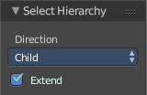
Last Operator Select Hierarchy
Child Extended, Parent Extended, Child and Parent share the same Last Operator. Called Select Hierarchy.

Direction
Direction is a drop-down box where you can adjust if child or parent objects gets selected.

Extended
This checkbox defines if the selection is extended or not. Extended means that it keeps the active object in the selection, even when it's not currently selected.

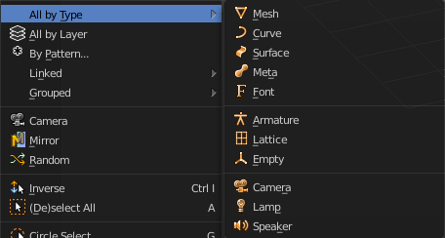
All by Type
All by Type is a menu where you can choose between the different object types to select.
The menu items are pretty self explaining. So we won't cover every single menu item here.

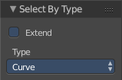
Last Operator Select By Type

Extend
With this option activated the selection does not clear before performing the selection operation, but extends. This means when you have a mesh object selected, and want to select all objects by type curve, then the mesh object is still selected. Without Extend just the curve objects are selected. The mesh object gets deselected.

Type
Type is a drop-down box where you can choose the object type to select again.

All by Layer
Selects all object in the defined layer.
You need to define the layer in the last operator panel. It's not enough to switch to let's say layer three, then perform the tool. The default value is Layer 1.

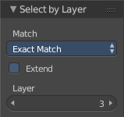
Last Operator Select by Layer

Match
Match is a drop-down box where you can choose if you want to select the objects that just exists at the current layer only. This is the option Exact Match. Or if you want to select objects too that exists at more than one layer. This is the option Shared Layers.

Extend
Extends existing selection instead of deselecting everything first.

Layer
The edit box where you can define the layer where you want to select the objects at.

By Pattern
Selects all objects whose name matches the entered string. For missing parts you need to add an asterix.
For example, you have four cubes in the scene. Cube, Cube.001, Cube.002 and mycube3. Then the term " Cube " will just select the first cube. While the term " Cube* " will select the first three. And " *cube* " will select all four.
Supported wild-cards:
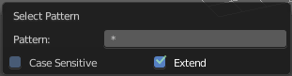
* matches everything
? matches any single character
[abc] matches characters in “abc”
[!abc] match any character not in “abc”
The tool operates immediately at entering the string.

Pattern
Here you can type in your string.

Case Sensitive
When ticked then the string comparison happens by taking upper and lower letters into account.

Extend
Extends existing selection instead of deselecting everything first.

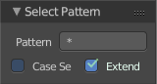
Last Operator Select Pattern
The Last Operator Select Pattern contains the same menu items than the pop-up.

Pattern
Here you can type in your string.

Case Sensitive
When ticked then the string comparison happens by taking upper and lower letters into account.

Extend
Extends existing selection instead of deselecting everything first.

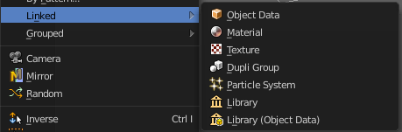
Linked
Linked is a menu where you can select different types.
Here you can select all objects that shares a common data-block with the active object. Select Linked uses the active object as a basis to select all others.

Object Data
Selects every object that is linked to the same Object Data.

Material
Selects every object that is linked to the same material data-block.

Texture
Selects every object that is linked to the same texture data-block.

Dupligroup
Selects all objects that use the same Group for duplication.

Particle System
Selects all objects that use the same Particle System.

Library
Selects all objects that are in the same Library

Library (Object Data)
Selects all objects that are in the same Library and limited to object data.

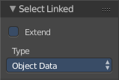
Last Operator Select Linked

Extend
Extends existing selection instead of deselecting everything first.

Type
Type is a drop-down list where you can choose the Linked type again.

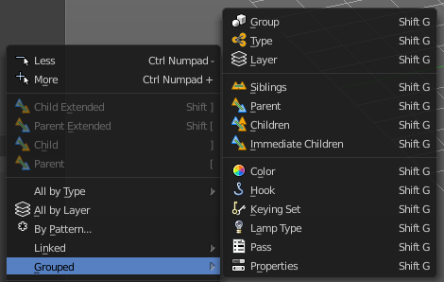
Grouped
Grouped is a menu where you can select different types of objects within the group. It requires to have a group selected.
The menu items are pretty self explaining. So we won't go into detail here.

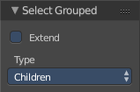
Last Operator Select Grouped

Extend
Extends existing selection instead of deselecting everything first.

Type
Type is a drop-down list where you can choose the Linked type again.

Camera
Selects the active camera.

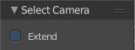
Last Operator Select Camera

Extend
Extends existing selection instead of deselecting everything first.

Mirror
Select the mirrored parts of an object. For example for L.Sword it selects R.Sword.

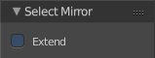
Last Operator Select Mirror

Extend
Extends existing selection instead of deselecting everything first.

Random
Selects random objects.

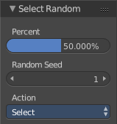
Last Operator Select Random

Percent
The Percentage of objects that should be selected randomly.

Random Seed
The Seed for the random number generator.

Action
Action is a drop-down box where you can choose if you want to select or to deselect random.

Inverse
Inverts the current selection.

(De)Select All
Toggles between select all and deselect all.

Last Operator (De)Select All

Action
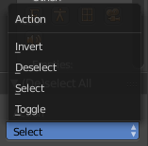
Action is a drop-down box where you can choose between different methods.

Invert
Inverts the selection.

Deselect
Deselects all.

Select
Selects all.

Toggle
Toggles between select all and deselect all.

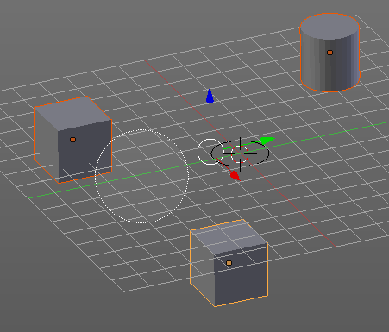
Circle Select
Circle select enters the Circle Select mode. This is a special select mode where you can select elements by moving with the mouse over it. It adds to selection by default.
To subtract from selection hold down Shift key. To exit the Circle select click with the right mouse button.
The pencil radius of the circle select tool can be adjusted with the scroll wheel.

Note
You cannot navigate while you are in Circle Select mode. You have to leave the Circle Select mode, do the navigation, then re-enter the Circle Select mode.

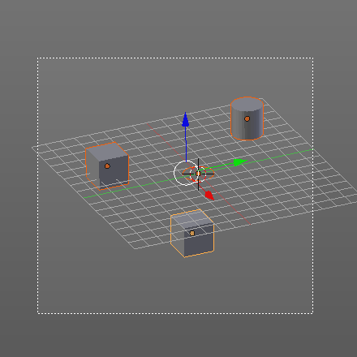
Border Select
Border select enters the Border Select mode. This is a special select mode where you can select elements by dragging a rectangle. And what's inside of the rectangle gets selected then. It adds to selection by default.
To subtract from selection hold down Shift key.
The selection gets applied when you release the mouse. You leave the mode automatically when you release the mouse.

Lasso Select
Lasso select enters the Lasso Select mode. This is a special select mode where you can select elements by dragging a form around what you want to select. And what's inside of the rectangle gets selected then. It adds to selection by default.
To subtract from selection hold down Shift key.
The selection gets applied when you release the mouse. You leave the mode automatically when you release the mouse.

Note
You can of course also start with clicking at the menu item. But this tool is by design a hotkey only tool. Hold down Ctrl , and select with left mouse button.

Stroke Select
Stroke select enters the Stroke Select mode. This is a special select mode where you can select elements by moving with the mouse over it. It is somehow similar to the Circle select tool. But has no pencil size. At the contrary, here you can navigate while you are in stroke select mode.
It adds to selection by default. To subtract from selection right click to change to deselect mode. This can also be done in the Properties sidebar in the Stroke Select panel. To return to add to selection right click again. Or untick the menu item in the Stroke Select Panel.
Note
This tool is by design a hotkey only tool. Hold down the key combo Shift Q, and paint with left mouse button.

Stroke Select is an add-on, and can be uninstalled if wanted. But note that the functionality is not longer available then.
